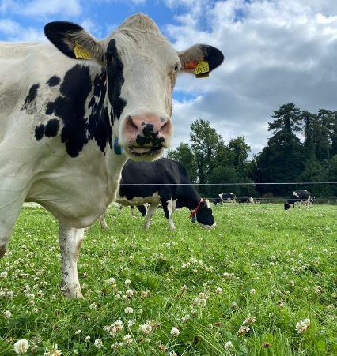
Project Objectives

- To develop a sustainable high-output grass-based spring milk production system
- To incorporate the most recent advances in grassland management for dairy farms into a high- output system
- Use a type of dairy cow that has good genetic indices for both milk production and fertility
- Employ the best practices from nutrition research and dairy cow husbandry
- Incorporate nutritional studies into a high-output system
- To incorporate management technologies and system attributes that enhance the sustainability of dairy production
Farm Details Week 10th– 16th July 2023
Stocking rate on MP (LU/ha) | 3.27
Farm Cover (kg of DM/ha) | 731
Growth Rate (kg of DM/ha/day) | 59
Demand (kg of DM/ha/day) | 56
Average grass DM (%)
Average Concentrate fed (kg/day) | 3.6
Average DIM | 161
Cow Details Week 19th - 25th June 2023
Yield (kg/cow/day) | 31.5
Fat (%) | 4.54
Protein (%) | 3.62
MS (kg/day) | 2.58
SCC | 59,000

Grassland Management:
Grass growth has really responded to fertiliser seeing steady increase in growth rate just ahead of demand. The 5kg DM/ cow of silage was removed from the diet on Tuesday the 25th July as cover/ LU has risen above 220 kg DM/LU (224 on Monday 31st July walk). To date 42 grass walks have been completed on the systems platform since January. The grass quality is being reflected in the tank with a raise in litres from the previous week.
Comments:
The cow which was ear marked as a pre-breed cull due to poor udder conformation was dried off on Friday 26th July. She had been milking in only 3 quarters and had developed chronicle mastitis in one of the remaining 3 Quarters. She was in her 7th Lactation so had served her time well on the systems project. She averaged 7492 kg Milk over her 7 lactations

Lact | Milk Kg | Fat Kg | Prot Kg | Fat% | Prot% | F+P Kg | Days
7 | 48588 | 2275 | 1777 | 4.68 | 3.66 | 4052 | 1910

We will take a break for August from the notes and will recommence in September again

